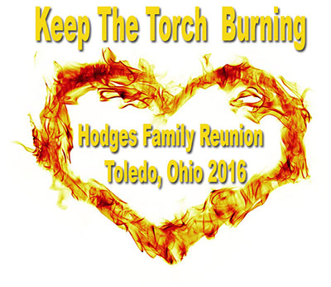Registration
July 15-17, 2016
Name(s) of Attendees:
Address:
Contact No. #:
Number of Adults (21 and up):
Number of Children (17 and under):
Cost Number Totals
Adult Ages (21 and up) $60
Children Ages (13-19) $20
Children Ages (5-12) $10
*Free*Any Adults 75 yrs. and older/4 yrs. and under*Free*
A count will be needed for Hotel Buffet and Dinner accommodations
Please Return Registration Forms in along with payments to
P. O. Box 3136, Toledo, Ohio 43607
Make all checks or money orders out to Errika Bates no later than May 30th, 2016
Please make your Hotel Reservations at the Ramada for $90/night
3536 Secor Rd, Phone Number: (419) 535-7070
Check–in Time: 3:00 pm
T-shirt order form will be forth Coming Soon.

